# Jian Wu Project 1 description

My project is a website which allow people to post item they want to sell and also let people to find the used or new item and provide the contact information to them.

Them home page is the main entrance of the whole website. 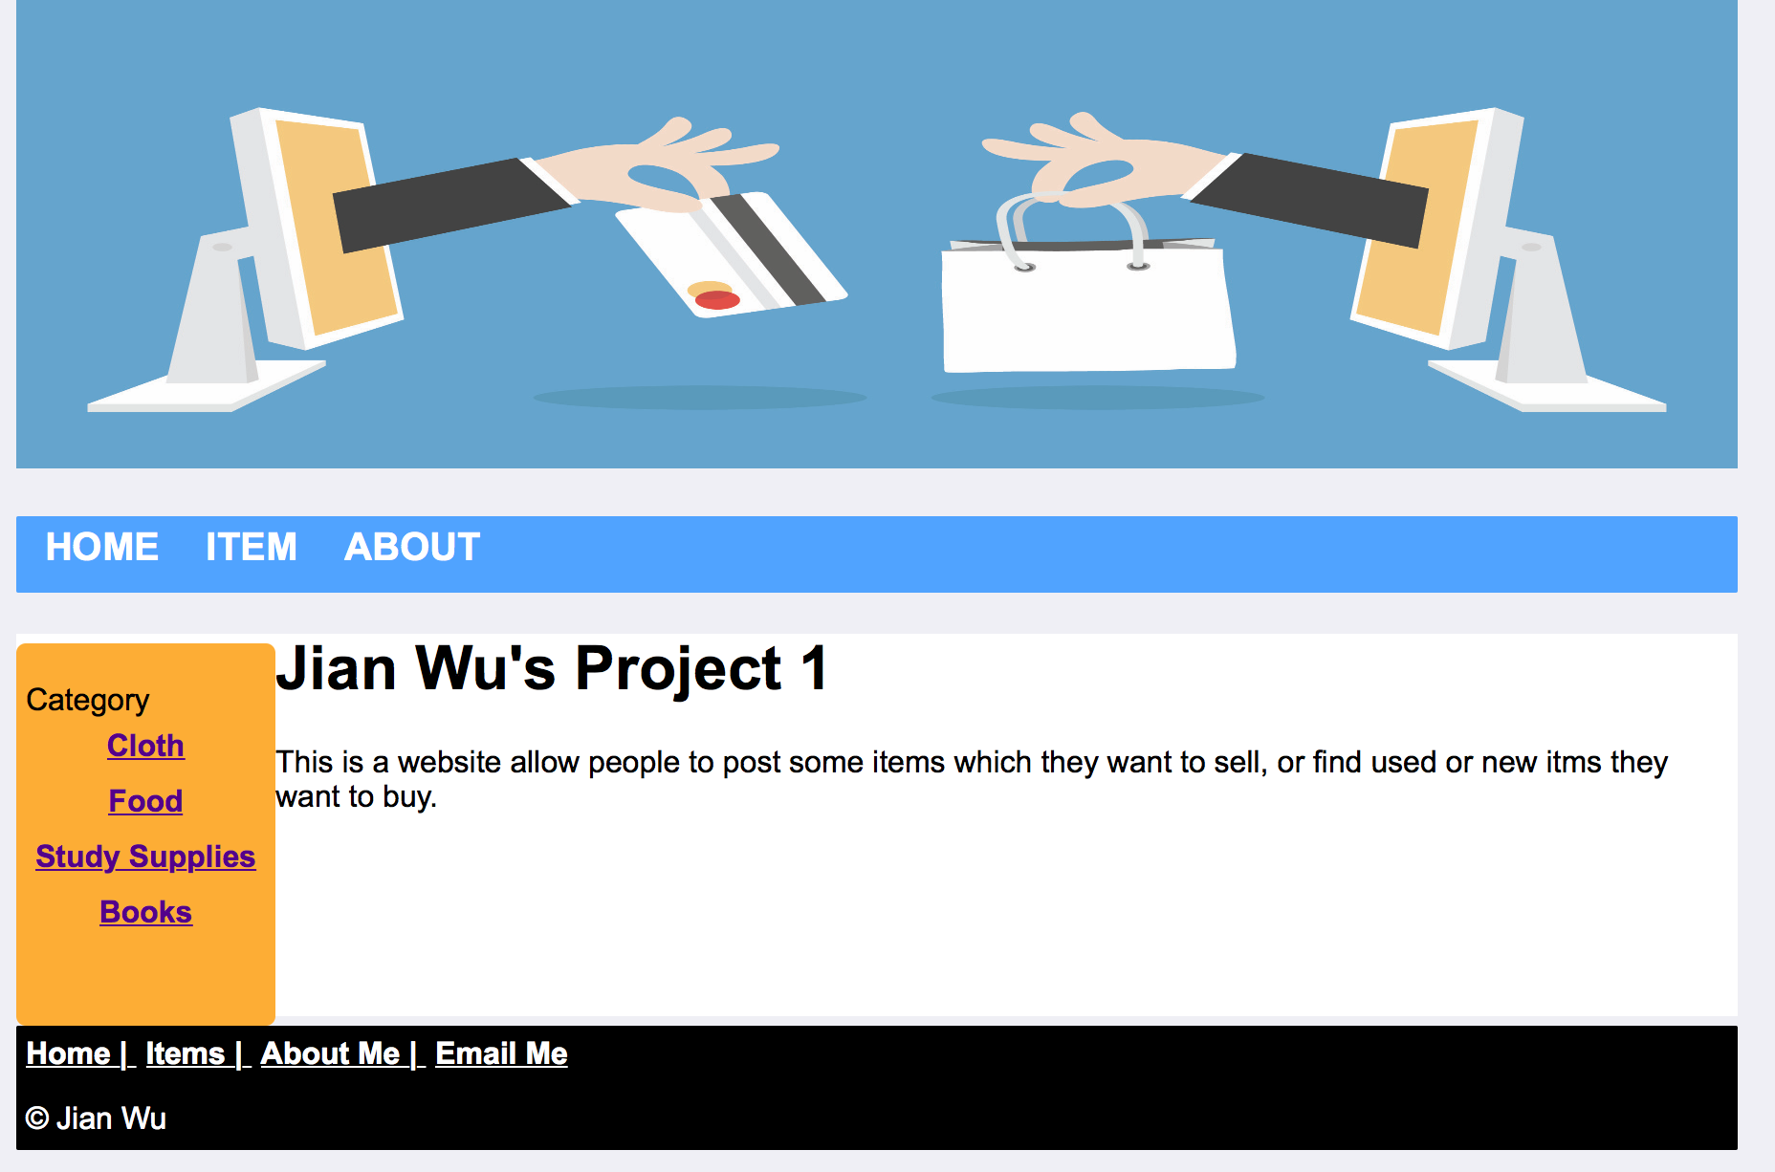

The item page shows the current item in the web site. By click the picture of the in the table you can enter the details description page.

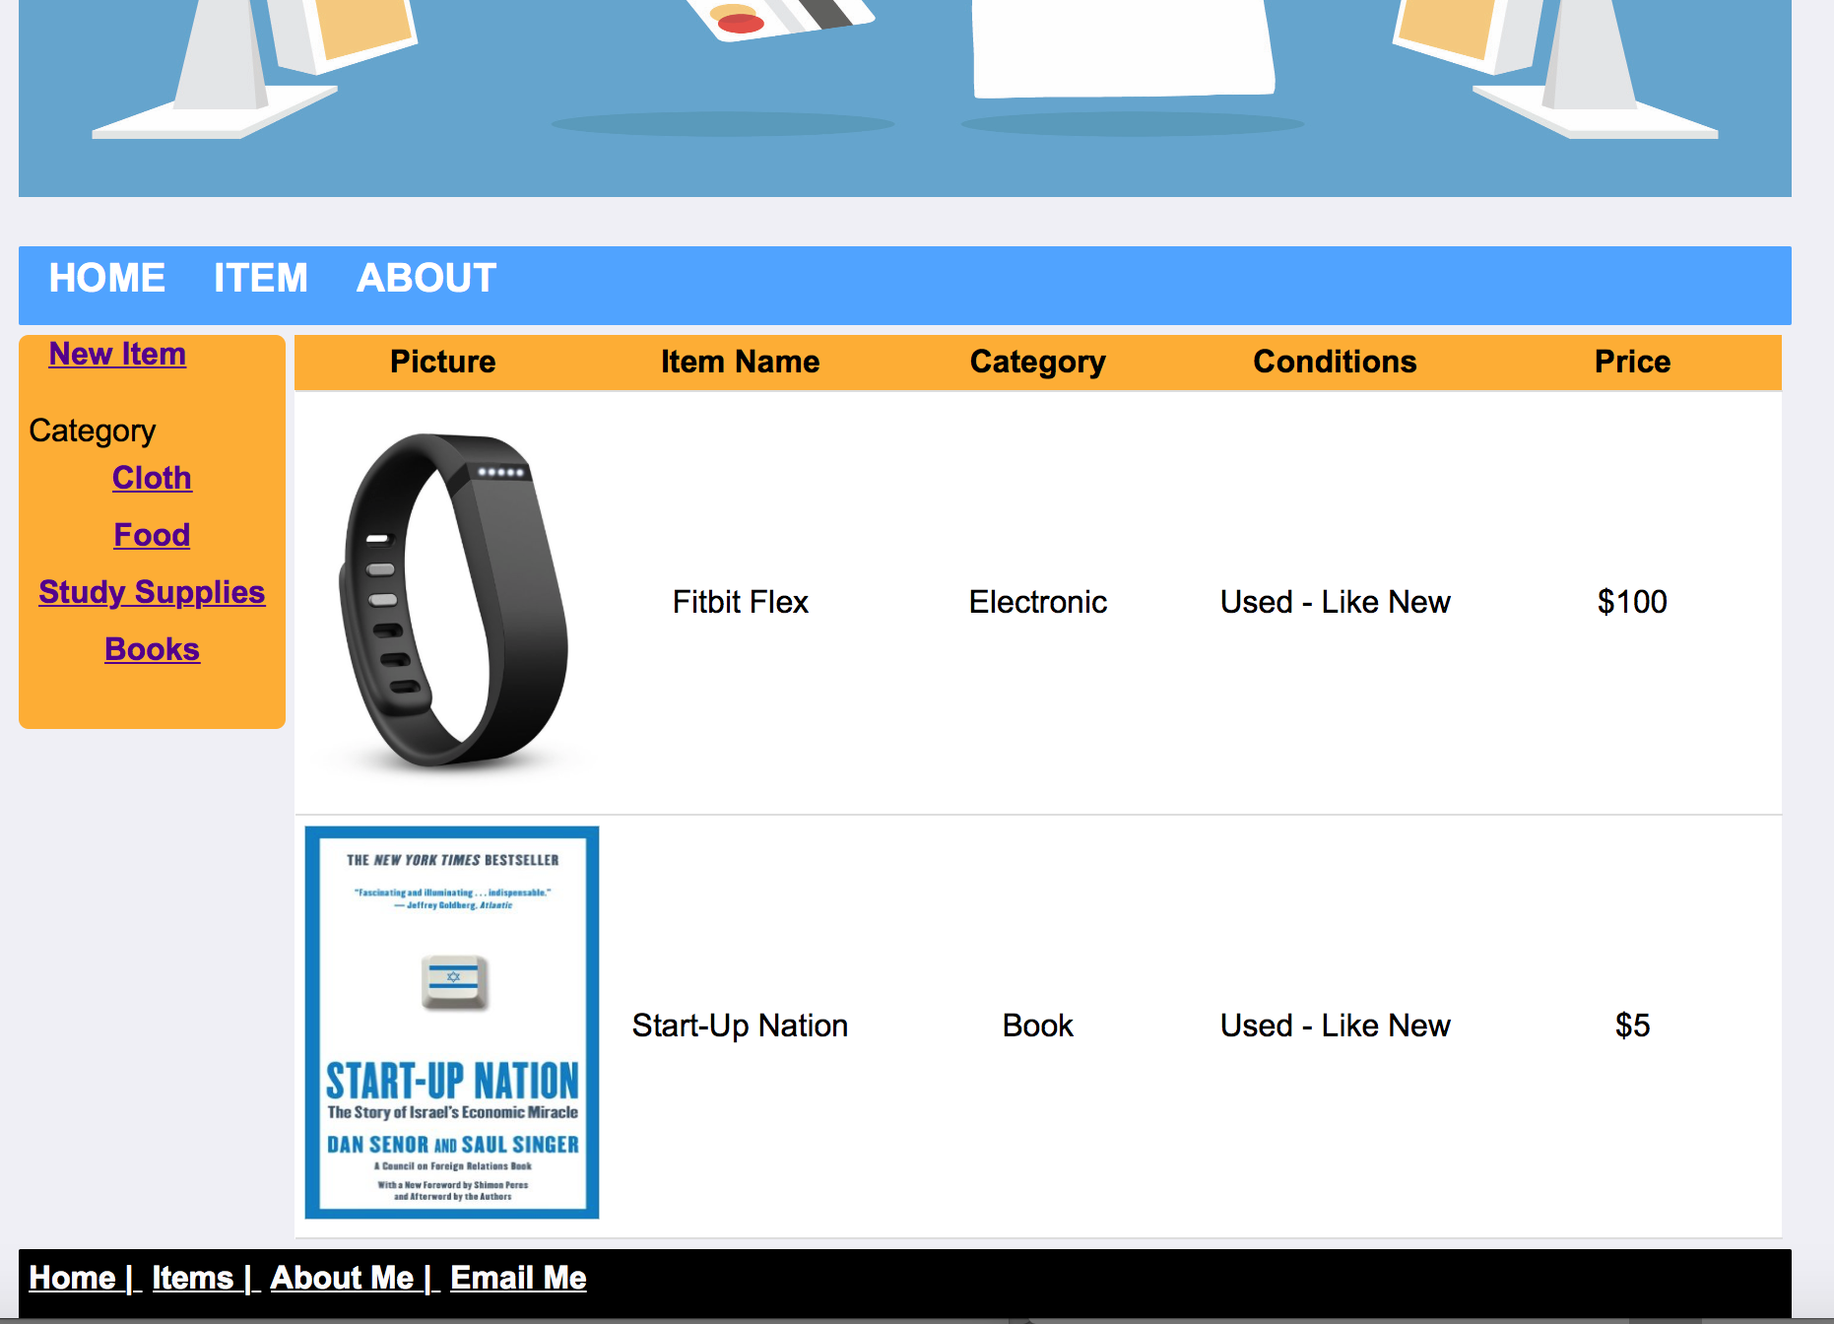

The Details description page shows all the information about the item, and also a button at the bottom of the table allow you to go back.

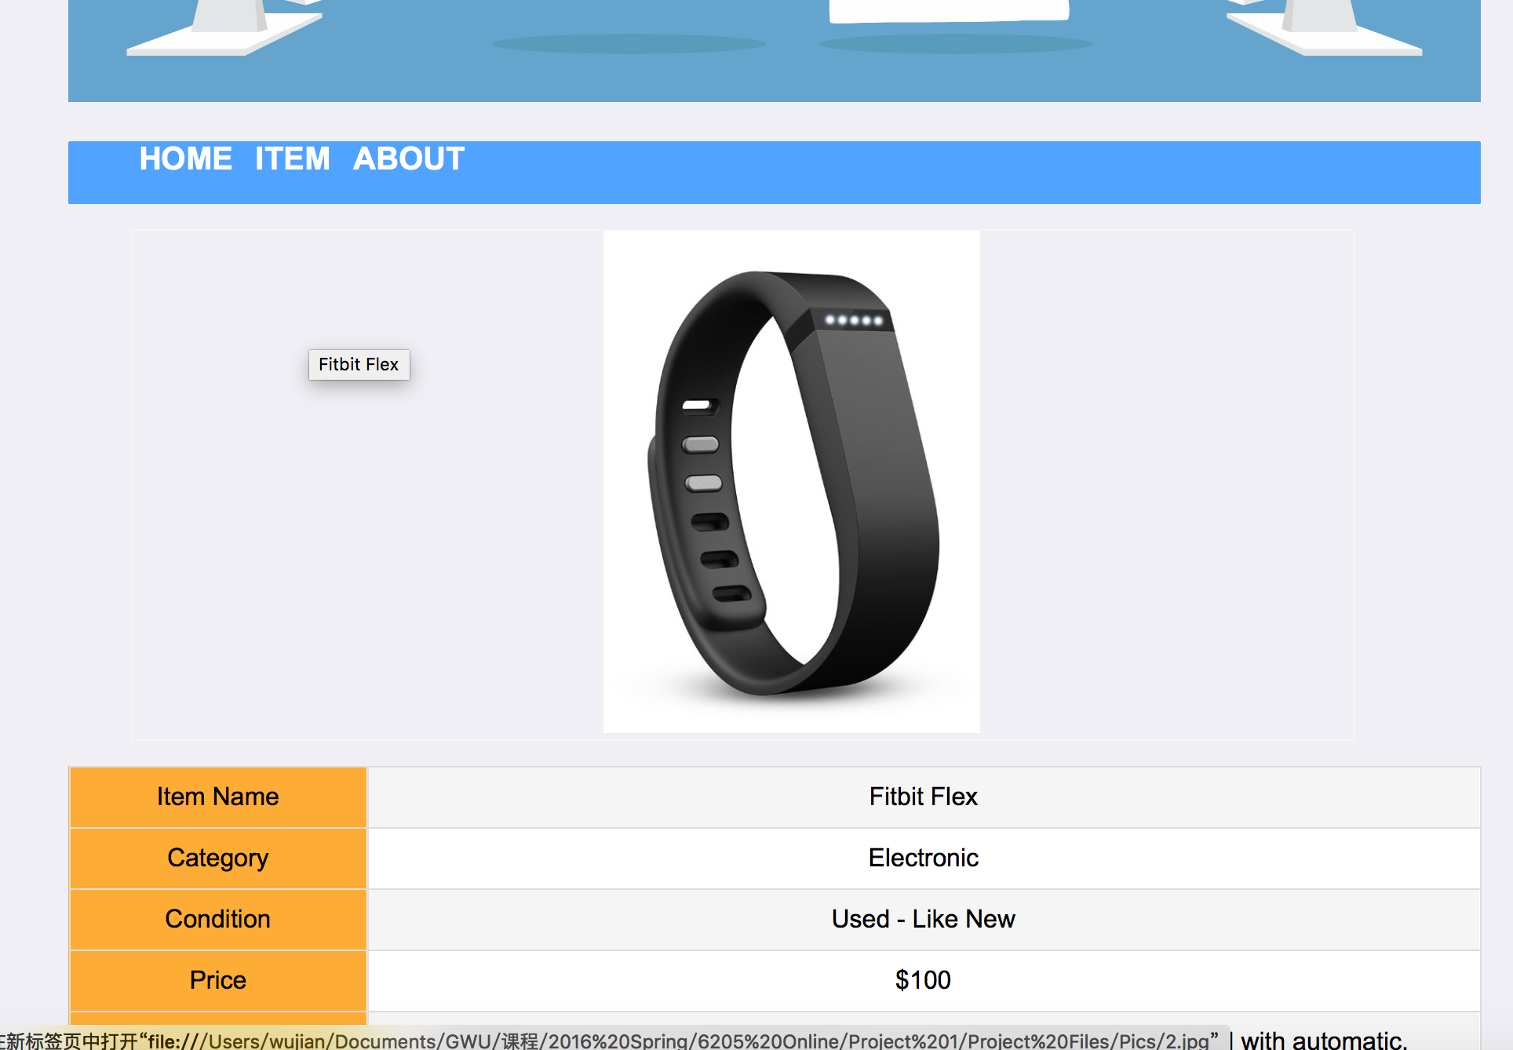

The “New Item”link in the ITEM page on the side bar is the entrance to add new item to the website. All the input field has a validation for nut NULL and the format and file type.

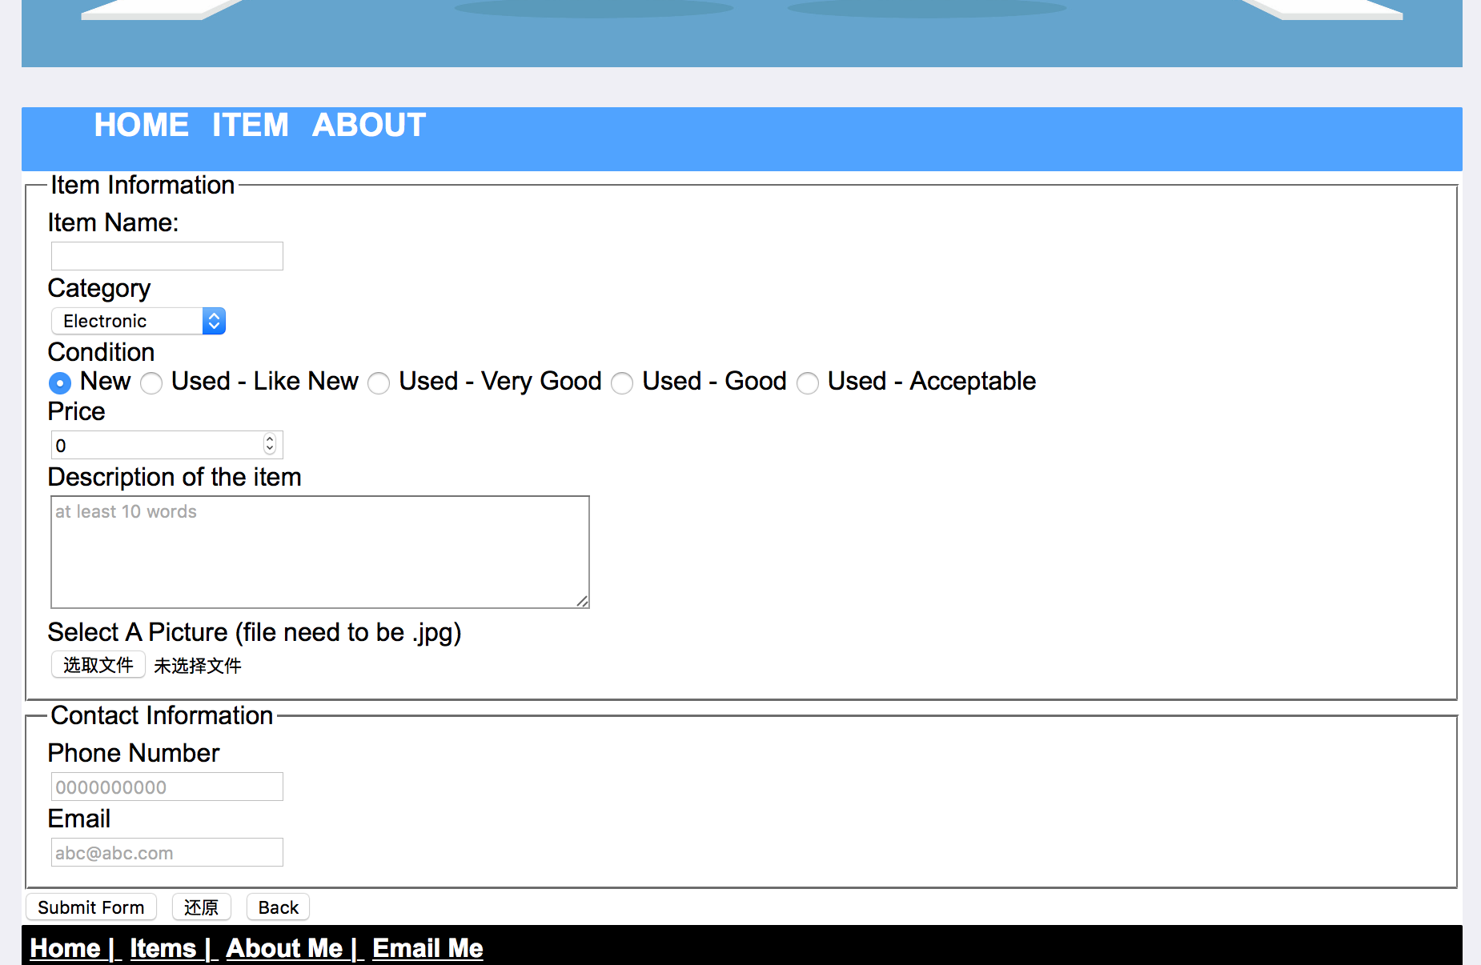

All pages support smaller mobile devices.